# HOME



CREATING A DIGITAL ENABLED, SECURED, AFRICAN CONTINENT

# WHO WE ARE

IntelliBesT® Global System Limited (IGS) is registered with Federal Republic of Nigeria under the allied matters decree of 1990. IntelliBesT Global System LLC is also register with the State of Arizona, USA. IntelliBesT core competncies in Egineering Procurement Construction and Installation (EPCI) are as follows:

1. **Engineering:**

**Front-End Engineering Design (FEED)**

IntelliBest® excels in providing Front-End Engineering Design (FEED) services, essential for defining project scope, costs, and schedules. FEED services minimize risks and ensure the feasibility and viability of projects from the outset. By emphasizing early-stage planning and in-depth analysis, IntelliBesT® establishes a robust foundation for successful execution. For example, in the Grand Petroleum Ethanol Refinery Project in Ghana and Amuwo Odofin Nigeria, Globalcom Cell Stations and Multilink Cell Station, DeltaAfrik Egina System Control Project. IntelliBesT®’s FEED work encompassed defining project parameters, integrating advanced technologies, and ensuring alignment with industry standards. Their capacity to handle large-scale and complex FEED projects demonstrates their expertise in setting up projects for assured success.

• **Detailed Engineering**

IntelliBesT® offers comprehensive Detailed Engineering services, delivering accurate design documents and specifications that guide construction and installation processes. This includes developing detailed plans and technical specifications to ensure accuracy and compliance with project requirements. Their detailed engineering for the Central Bank Of Nigeria ICT and Security projects involved cutting edge technology in ICT infrastructure EPCI. McDermott's ability to handle high-capacity and technically challenging projects showcases their precision and reliability in detailed engineering.

• **Specialized Engineering**

Renowned for its expertise in Specialized Engineering, IntelliB esT® tackles complex projects such as 4G NOCs, Fiber Optics, System Command and Control Center, and large-scale Housing Development facilities. Our advanced engineering solutions and cutting-edge technology are exemplified by the work we did for different clients in Nigeria and Ghana and Other African Countries. Our capacity to deliver innovative engineering solutions in challenging environments underscores our leadership in specialized engineering.

**Procurement:**

• **Supply Chain Management**

IntelliBesT® manages procurement through an extensive global supply chain network, ensuring high-quality materials and timely delivery. Our supply chain management is crucial for maintaining project timelines and quality standards. For example, in the CBN and Multilink projects IntelliBesT® global network facilitated the procurement and delivery of critical components, including several tons of equipment and materials, on schedule. Our capacity to handle large-scale procurement logistics demonstrates their efficiency and effectiveness in managing supply chains.

• **Vendor Management**

IntelliBesT® Vendor Management focuses on ensuring that subcontractors and suppliers adhere to strict quality standards. Their rigorous oversight maintains high standards across all project phases. In the DeltalAfrik Egina project in Nigeria, IntelliBesT® managed multiple vendors to meet the project's extensive requirements, ensuring compliance with quality standards for over 20,000 tons of fabricated steel. Their capacity to coordinate with a diverse range of vendors highlights their expertise in maintaining project quality and consistency.

# CORE COMPTENCE

1. Information Communication Technology Infrastructure Development
   1. 3G, 4G, 5G Telco Network Operating Centers Engineering, Procurement Construction and Installation (EPCI)
   2. Intrusion Proof Security Infrastructure in both Classified and Conventional deplozment
   3. Engineering, Procurement, Construction and Financing for capital Intensive Projects
2. Real Estate and Construction
   1. Mass Housing and Luxury Homes Construction for Government and Private Entities.
3. Oil and Gas Petrochemical
   1. Refinery Construction and Joint Venture Financing
   2. Refinery Health Safey and Environmental (HSE) Evaluation and Upgrade
   3. Oil Well and Pipeline Construction and JV/BOT Financing
4. Agriculture and Agro-Industrial City
   1. Joint Venture/PPP/ EPC delievry of large scale agro-indutrial city

# Our Vision

Our vision n is to provide a competitively value-driven, customer oriented and excellent services aided by highly skilled manpower and seasoned Technical Partners in the area of Information Communication Technology (ICT), Multimedia-High Tech Security, Telecommunication, Energy and Agriculture

# Mission Statement

Our projects become mission accomplished when it has provided a competitively value-driven, customer oriented and excellent services aided by highly skilled manpower and seasoned Technical Partners, outstanding after sale services in the area of Information Communication Technology (ICT), Multimedia-High Tech Security, Telecommunication, Energy, Power, Real Estate and Agriculture

# Board of Directors Members

1. Dr Solomon Adeleye
2. Engr. Omoniyi Oladimeji
3. Engr. Ayodele Ogunjebi
4. Barrister RopoFabusuyi

## Senior Members of Technical Staff

1. Dr. Solomon Adeleye
2. Engr. Ayodele Ogunjebi
3. Engr Adeoye Alalade
4. Engr. Omoniyi Oladimeji
5. Engr. Oluwatoyin Omisore
6. Mr. Osanyinbi Soyibola Dickson:
7. Barr Ropo Fabusuyi

## 4.1 Details of Principal Specialists

### Dr. Ajibade Solomon Adeleye PhD- Chairman

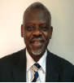 **SUMMARY** – Solomon holds a doctorate in chemical engineering from Imperial College, University of London, United Kingdom (UK) with over 30 years experience working in Nigeria, the UK and internationally on a wide a range of environment (oil/gas and chemical industries) projects. His diversified working experience in chemical and environmental setting include, applied experience in feasibility studies, process operations and development, process equipment installation, pilot testing and commissioning, environmental audit, environmental impact assessment, due diligence studies at fuel stations, oil terminal (bulk storage) and nitrogenous fertilizer complex, baseline environmental assessments, environmental site assessment, remediation of contaminated sites, project administration and management, field inspection, water and water and wastewater management.

Solomon has worked in both Victoria and Vancouver offices in British Columbia Canada, and Lagos office to gain experience in environmental issues facing commercial, upstream and downstream sector of the oil industry. He has recently completed projects in Kenya, Nigeria, Tanzania and Uganda. Solomon worked as a Project Manager for Sub Saharan African Countries with extensive experience of managing projects; regularly interface with clients, local authorities and regulatory bodies. He is a member of the Association of Professional Engineers Geoscientist British Columbia (APEG BC).

### Engr. Ayodele Timothy Ogunjebi – Managing Director

Summary: Currently I am the Managing director of IntelliBesT® Global Syatem Ltd. IntelliBesT® is a major player in real estate development, Telecommunication consulting company with home office at Ajah,

Lagos Nigeria. My duties include researching for developable

properties with enuine ownership that has unencumbered documentations such is registered survey plans, certificate of occupancy, governor consent,

Supreme Court judgment, etc. In my role for the company, I also handle engineering and

procurement of the latest technology that can make the company outclass its competitors.

Continuously seek investors to invest in our company. I manage daily activities of the company. I

oversee the activities of the engineering department and ensure that installations are done correctly.

Also, I continue to seek the cheapest way to do business with foreign companies so that we can save

Nigerian subscribers some money and ensure that their business can survive by providing services to

them at a fraction of what our competitors charge. Prior to employment in Nigeria, I was a senior

Application Engineer, and later became the team manager of the Communication Product Group of

Intel Corporation in United State of America. My job included managing both the technical financial

and human factor aspect of the application engineering team. My team companies of ten engineers,

three technicians, and two non-engineering staff. I was responsible for a budget of over $75Million

annually, I was the Technology Transfer Team Lead for 802. 16e-WiMax Technology for Intel

Communication Chipest Group. I have clear understanding of WiFi- WiMax Telecommunication

Technologies from Silicon Level to System Integration. Engr. Ayodele holds a Bachelor and Master

degree in Electrical and Electronics Engineering from California State University Sacramento and An

MBA degree from University of Phoenix, Arizona. Engr. Ayodele is a North America certified electric

power engineer.

### Brig. Gen. L. O Adeoye (RTD): Director Military and Para-military Ops

Brig. Gen Adeoye was commissioned into the Nigerian Army after successful completion of post-secondary school the three year in June 1981. Thereafter he attended and successful completed several university and military senior level courses including a Master of Science Degree from the Prestigious University of Ibadan in 2010. Enumerated below are some of the positions he held while in the Nigeria Defense Service.

* 223 Tank Batalion (232 TK BN) Kaima/Shaki: Coy Comd Internal Security Troop Commander, Sport Officer- 1981-1983
* Nigerian Army Armour School (NAAS) Driving and Maintenance, Eagle Main Battle Tank 1 Instructor 1983-1985. HQ 23 AmouredBrigade, Bauchi- 1985-1988.
* NAAS: Driving and Maintenance Eagle MAIN Battle Tank, 1 Instructor at Nigerian Army Armour School, Bauchi, 1988-1991
* AHQ Dept of Military Secretary ‘Army’, Assistant Deputy MILITARY Secretary -4-1994-1995. AHQ Dept of MS ‘A’ Assistant Deputy Military Secretary -5 1995-1996-1996 (1995-1996). ACCS: Senior Instructor (SNR INSTR) Tactics; 1997-1998. ACCS: SNR INSTR Automotive Dept from 1998-1999. HQ 3 Div. SO1 A/Q: 1999-2000 (Staff Officer Grade 1 Administration and Quatering)

### Engr. Omoniyi Oladimeji: Executive Director, COREN, WSO-CSE

Engr. OmoniyiOladimeji is a Quality, Health, Safety, Environment and Security (QHSES) Professional with over 25 years of experience translating excellent safety and quality performance into profitability and operational excellence in the Oil and Gas Industries. He is the current Group QHSSE Director for

Deltatek Group and Africa Regional Director of Assurance(HSE, Risk, Quality, Security) for

Worley Group. Omoniyi current role is to assist the Worley group across Africa

business in achieving its business strategy objectives, provide subject matter expertise and give hands on support to deliver successful commercial, contractual and sustainable outcomes on projects, leverage the global assurance knowledge and networks and work with local leaders and projects across Africa to strengthen awareness and management of risks in compliance with Group values, and local regulations, obligations and laws

He holds a master’s degrees in electrical engineering (M. Tech) from Rivers State University of Science and Technology and another in Business Administration (MBA) from University of Ado Ekiti. He is current pursuing his PhD program in Safety and Environmental Technology with University of Port Harcourt.

He is a COREN registered Engineer, a World Safety Organization Certified Safety Executive (WSO-CSE), A fellow of Nigeria institution of Safety Engineers (FNISE), A fellow of Institute of Management Consultant (FIMC), A fellow of Professional Leadership Practitioner Institute (FPLPI), a certified United State of America OSHA trainer, and professional active membership of both local and international bodies such as American Society of Safety Professional (MASSP), Institute of Safety Professional of Nigeria (MISPON), Nigeria Society of Engineer (MNSE), IIRSM, World Safety Organization (MWSO), IEEE etc.

Engr. Omoniyi started his professional career with Shell Petroleum Development Company of Nigeria Limited in 1996. He served in various capacities as Project Engineer, QHSE Engineer for operations and projects in Lagos and Port Harcourt. He also worked as QHSSE & Community Affairs (CASHES) Manager with DSV Pipetronix/PII/ROSEN group for Major Pipeline Integrity Projects that cut across all major players (Shell, Mobil, Chevron, NLNG, Total etc) in both onshore and offshore, swamp locations of Niger Delta region of Nigeria. He joined DeltaAfrik (Deltatek and Worley JV company in Nigeria in March 2005 as Corporate QHSE Manager. He has also served in various capacities as WorleyParsons Africa HSE Manager and Sub-Sahara Africa Regional HSE Director for WorleyParsons group. Engr. Omoniyi, a committed believer of zero Harm in QHSES practice, has successfully transfer QHSE best practices across Worley offices in Africa with alignment and implementation of regional and global QHSE strategy.

Engr. Omoniyi is an executive Director of the company and will also be the lead principal Electrical Engineer and Lead Assurance (Quality, Risk, HSE, CSR, Security) Management for this project.

### Barrister Ropo Fabusuyi: MBA, LLM, MICS (Secretary and Legal Adviser)

Highly skilled Legal researcher and drafting with strong proficiency in procedural and substantive law with creative acumen in resolving matters

Work experience personal details:

* Wema Bank PLC between 1990-2010 (Retired as a Zonal Risk Manager, Northern States)
* Elbera Chambers (Principal partner) 2011-till date. Legal drafting and

documentation including knowledge of substantive law and legal procedure. Advocacy: Creative problem solving. Knowledge of commercial, maritime and international law.

* Member Institute of Chartered Shipbrokers, London

### Mr. Osanyinbi Soyibola Dickson: Geophysicist and Seismic Consultant

 Geophysicist with a vast experience in field operations in seismic operation for over 22 years exploring for oil and gas in numerous oil blocks for the Multinational Companies in the Niger Delta area of Nigeria. He has worked in managerial and supervisory capacities in the implementation of seismic operations contracts for SHELL, CHEVRON, EXXON MOBIL, NNPC, AGIP, PAN-OCEAN, The major operators in Nigeria on both land, swamp and offshore areas.

He also participated in the pre/post Environmental Impact Assessment of some key oil blocks in OML 28, 55, and 40 in the Niger Delta area. He was engaged by Shell Petroleum Development as a Company Site Representative (CSR) saddled with the responsibility of supervising and monitoring field operation projects to ensure compliance with company operation policies.

His working experience is not limited to oil and gas operations alone. He has Also worked with corporate organizations such as Bibstar-offshore services as a project supervisor in waste management and also Bellarich Industries as production manager.

The long years of experience has given him a good exposure in the Management of public and Government relations, social responsibility, conflict prevention & resolution management, deep knowledge of the politics of the Oil-bearing communities, worked and interacted with over 500 community leadership in Niger Delta areas. He is skillful in negotiation and dispute settlement, analytical reasoning, innovative solutions and strong passion for business development and has worked with people of diverse background

### James Robison: CEO Gideon Group (Investment and Financial Partner)

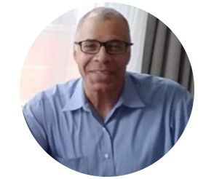The Gideon Group (www.gideongroup.net) is a leading provider of global corporate and project finance solutions. The Gideon Group Provides Funding for $488 Million Cambodian Solar Project in association with RAK Bank (www.rakbank.ae). Rak Bank a financial services provider of world-class products and industry-leading customer service to people and businesses across the United Arab Emirates. Understand the risk inherent in corporate strategy and the risk appetite of the management in executing that strategy

* Understand the critical assumptions underlying the strategy
* Be alert for organizational dysfunctional behaviour that can lead to ethical breaches, losing line of sight of on the Company’s brand promise or taking risks beyond the Board’s understanding of management’s risk appetite that neither the Board nor the investors will approve.
* Determine whether the entity has the appropriate strategies and capabilities in place to manage the Company’s risks.
* 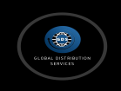

### Global Distribution Services (S) PTE Ltd (Investment and Financial Partner)

GDS - Singapore- Global Distribution Services (s) PTE Ltd is a company with specialization in private financial consultancy providing clients with atructured bank instruments for capital intsnsive projects, Private low interest banking facilities and secured low bank loans from top tier prime banks in Europe.

# CUSTOMERS

1. CBN
2. LAGOS STATE GOVERNMENT
3. TELECOM SERVICE PROVIDERS
4. NIGRIA DEFENCE HEADQUAERS
5. OIL AND GAS INDUSTRIES

# 6 CONTACT

Graphical User Interface for

Name

Phone

Email

Message

# PREVIOUS PROJECT ( Delivered to the delightment of our clints)

The Following are lists of some of the previous projects we have successfully delivered.

## 8.1 MULTILINK 3G EARTH STATION SITE (IBADAN-NIGERIA 2006

Project involve design, procurement and construction and installation of a self supporting 15o meter fix tower 2G and 3G mast to support voice, video, DSTv operations.

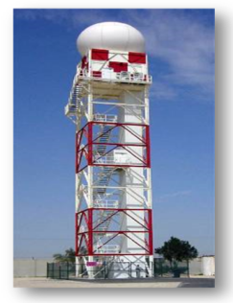

## 8.2 LAGOS STATE MARINE SURVEILANCE FOR WATER FRONT INFRASTRUCTURES -2017

Project involved installation of 97Km fiber optic ring across Lagos Water front for data transmission from the surveiallance mast to the control and emmergence response center in Alausa

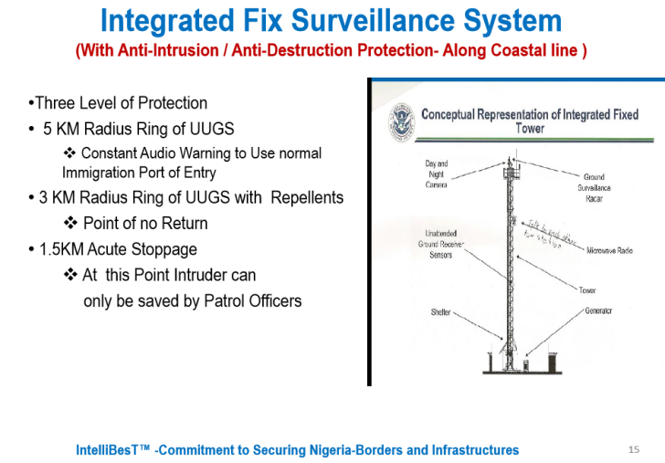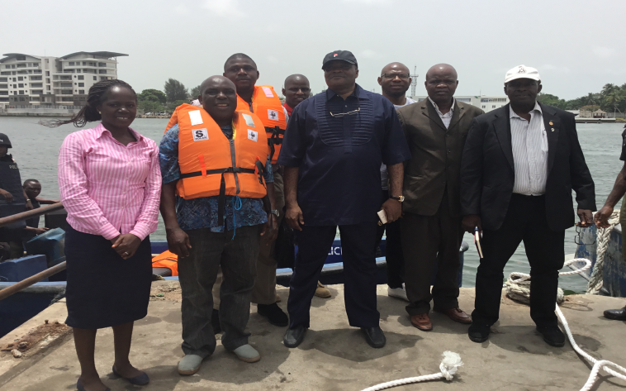

Reconnaissance group picture with SA to the governor on security.

## 8.3 CENTRAL BANK OF NIGERIA (CBN-2015)

Installation of DNT CCTV



## 8.4 Construction of Mass Housing Ondo State Nigeria- Subcontractor

**Two Bedroom Block Of Flats Sunshine Estate Ondo State Nigeria**

## 8.5 Five Bedroom Luxury House Victory Estate Lagos- Main Contractor

8.6 Oshodi Terminal Dedicated BRTLane Substitute Contractor

